Node.js is a runtime environment that allows you to execute JavaScript code on the server side.

It's built on the V8 JavaScript runtime and is designed to be lightweight and efficient for building scalable network applications.

Node js is fastrer than other programming or scripting languages

Asynchronous Programming: Node.js is designed to be non-blocking and asynchronous.

Example using callbacks:

**Installation:**

You can download Node.js from the official website: Node.js Downloads.

Once installed, you can check the version using:

node -v

create a directry with command

mkdir Node-application-name

cd Node-application-name

npm init -y

Install dependencies

Npm install express // Express is a popular web framework for Node.js.

Npm install ejs

Npm install body-parcer

Npm install bootstrap

Npm install nodemon

Open the project on visual studio code editor

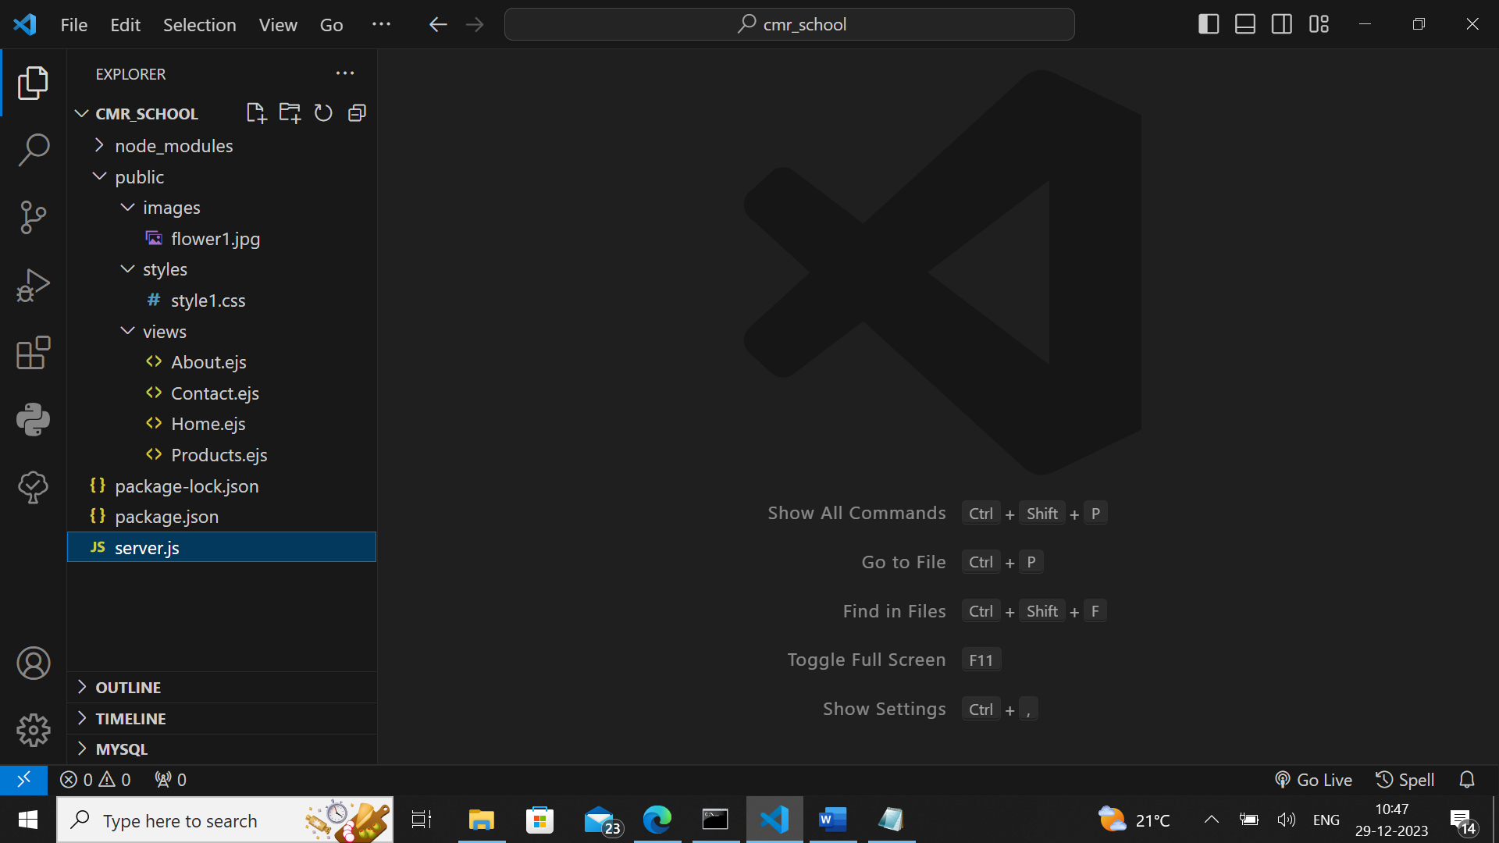

Create folders and files like show above

Creating a Server:

Node.js can be used to create web servers.

Create a file named server.js:

**Server.js**

const express=require("express");

const ejs=require("ejs");

const bodyParser=require("body-parser");

const app= express();

//setting the view engine as EJS.

app.set('view engine', 'ejs');

//roots the views directory to public

app.set('views', 'public');

//tells express that the public folder is the static folder

app.use(express.static("public"));

//home route

app.get("/", function(req,res){

res.render("./views/home");

});

app.get("/products", function(req,res){

res.render("./views/products");

});

app.get("/contact", function(req,res){

res.render("./views/contact");

});

app.get("/about", function(req,res){

res.render("./views/about");

});

app.listen(3000, function(){

console.log("SERVER STARTED ON localhost:3000");

})

**Public/views/Home.ejs**

<!DOCTYPE html>

<html lang="en">

<head>

<meta charset="8">

<meta name="viewport" content="width=device-width" initial-scale="1">

<title>Home</title>

<link rel="stylesheet" href="./styles/style1.css">

<link href="https://cdn.jsdelivr.net/npm/bootstrap@5.3.2/dist/css/bootstrap.min.css" rel="stylesheet" integrity="sha384-T3c6CoIi6uLrA9TneNEoa7RxnatzjcDSCmG1MXxSR1GAsXEV/Dwwykc2MPK8M2HN" crossorigin="anonymous">

<script src="https://cdn.jsdelivr.net/npm/bootstrap@5.3.2/dist/js/bootstrap.bundle.min.js" integrity="sha384-C6RzsynM9kWDrMNeT87bh95OGNyZPhcTNXj1NW7RuBCsyN/o0jlpcV8Qyq46cDfL" crossorigin="anonymous"></script>

</head>

<body>

<div class="continer">

<h1>welcome to home page</h1>

<a href="/about">About</a>

<a href="/contact">Contact</a>

<a href="/products">Products</a>

<br>

<img src="./images/flower1.jpg" class="image-rounded">

</div>

</body>

</html>

**Public/views/About.ejs**

<!DOCTYPE html>

<html lang="en">

<head>

<meta charset="8">

<meta name="viewport" content="width=device-width" initial-scale="1">

<title>Home</title>

<link rel="stylesheet" href="./styles/style1.css">

</head>

<body>

<h1>welcome to about page</h1>

<a href="/home">Home</a>

<a href="/contact">Contact</a>

<a href="/products">Products</a>

</body>

</html>

**Public/views/Products.ejs**

<!DOCTYPE html>

<html lang="en">

<head>

<meta charset="8">

<meta name="viewport" content="width=device-width" ,initial-scale="1">

<title>Home</title>

<link rel="stylesheet" href="./styles/style1.css">

</head>

<body>

<h1>welcome to Product page</h1>

<a href="/about">About</a>

<a href="/contact">Contact</a>

<a href="/home">Home</a>

</body>

</html>

**Public/views/Contact.ejs**

<!DOCTYPE html>

<html lang="en">

<head>

<meta charset="8">

<meta name="viewport" content="width=device-width" initial-scale="1">

<title>Home</title>

<link rel="stylesheet" href="./styles/style1.css">

</head>

<body>

<h1>welcome to Contact page</h1>

<a href="/about">About</a>

<a href="/home">Home</a>

<a href="/products">Products</a>

</body>

</html>

Go to command prompt and give the following command

Node server.js

Server will be start

And open browser

And type the command http://localhost:3000

